Assignment Interview question

Note :-

Please prepare the answer of these questions in brief :- (in your own words)

- What is the need of IAM?

Ans. IAM is useful for segregation of users as per security, monitoring & cost point of view.

- In terms of security the it is necessary to restrict the access to resources, user should not able to do any changes in the infrastructure which can affect the cost of project

- In terms of security, we can secure/restrict access to any resource/service by applying certain policies to IAM user.
- There are serives like CloudWatch, WatchGuard ect which can be use to track and monitor the activities performed by IAM users in very effective manner, it help us to find the root cause of any incident.

- If i am a non tech person, how will you define policies in IAM.

- Please define a scenerio in which you would like to create your on own IAM policy.

Ans. If I have team and there is one project which involves DBA team, Server Team, Security Team.
Then we need to create IAM users according to team and we will create the groups and assign polices so they can only access the resources which are required for their work.

Note – Not every team should have access to billing dashboard of our AWS account and by default the access to billing dashboard is disabled for IAM users.

- Why do we prefer not using root account?

Ans. One of the main reason is security, any hacker can root into our account and he can lock us out and even change the password. This will be disastrous they can take down our server etc.
It is recommended to use sudo to install any package/dependencies, so we can revert the changes or revoke the access to user.

- How to revoke policy for an IAM user?
Ans. Below is the screenshot of removing the policies of IAM user

Under IAM\users, select the user and under permissions tab we can remove the policy like AmazonECS_FullAccess.
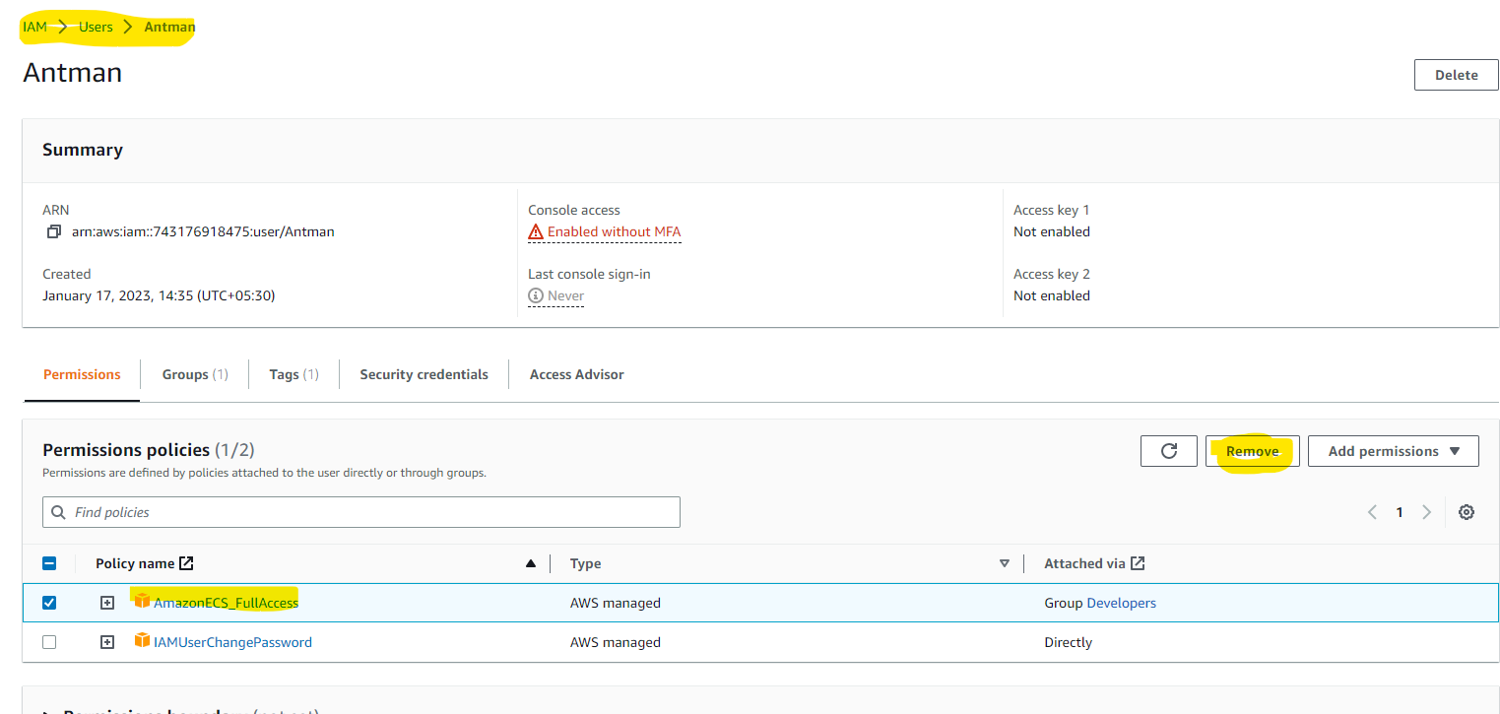
There is another way, if the user is member of some group then we can remove the policies from group then eventually user will not able to access that policy
1. 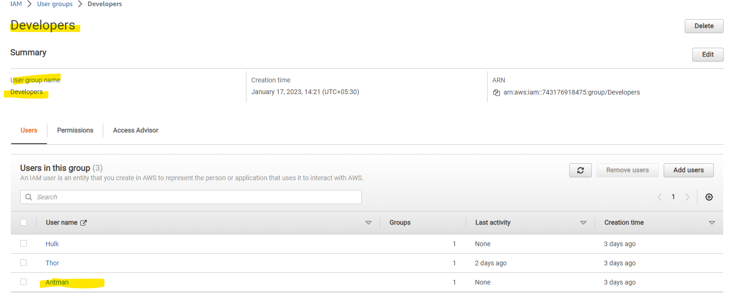
2.If we remove polices from group tanc check the user polices and it that policy will be automatically removed for all the users whoever is the member of that group.
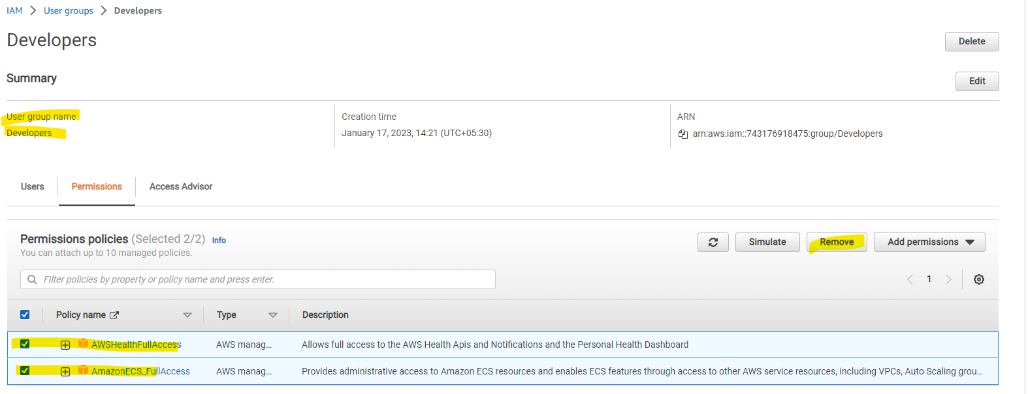

3.Now we can see only policy applied to user, which was explicitly assigned to the user

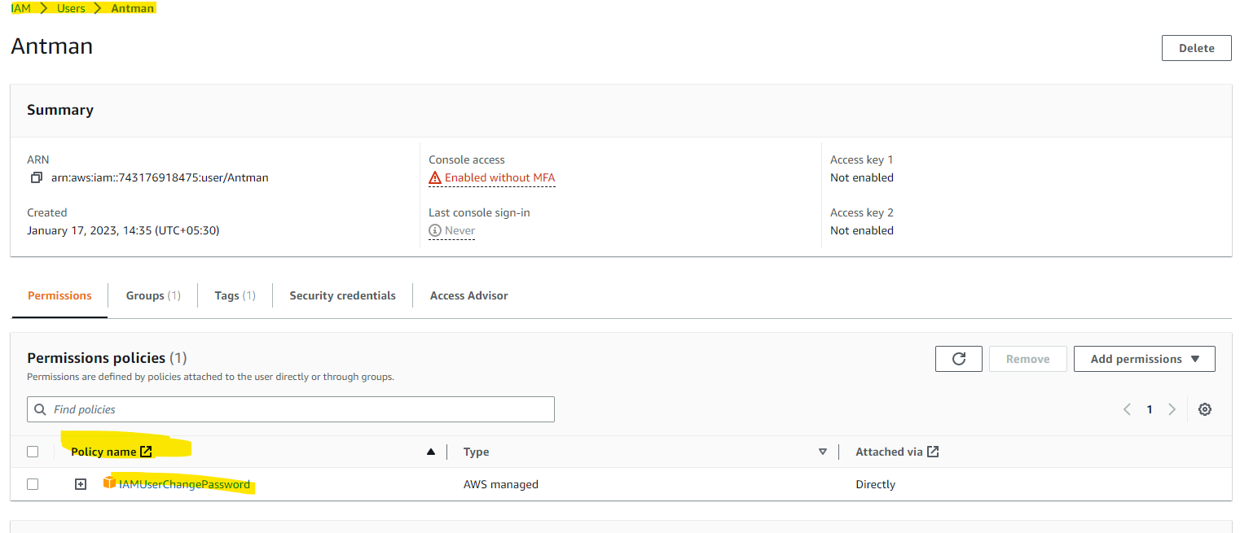

- Can a single IAM user be a part of multiple policy via group and root? how?

Ans- Yes. A single IAM user can be part of multiple polices and polices can be imposed on users via groups also.
We can provide “AdministratorAccess” policy which has highest level of access administrative among other polices.

Note – The “Service Control Policies” can be used for revoke/restrict the permissions to Root account.

